**Global Power Plant and Energy Consumption Visualization**

**Z1906565**(Teja Maridi)

**Z1949756**(Rakesh Kamma)

Contents

Introduction 3

Dataset Description 3

Attributes types 4

Research Questions 4

Description of visualization 5

Evolution of design 6

Marks and channels 10

Techniques to build the application 10

Visualization to Answer the question 10

How does the country's geographical location influence on type of power plants? 10

Where did the initial power plant started and how is the growth of power plants across the world over the years? 12

How is one fuel type replacing other fuel types and how can we see the trends over the years? 14

What is the closest power plant to a particular power plant? 17

What is the attribute of a particular Power Plant in the world?. 18

Limitations and future work 19

References 19

# Introduction:

One of the three elements that make up total energy generation is electricity. The other two are heating and transportation.

As we look more closely, we see that the breakdown of sources—coal, oil, gas, nuclear, and renewables—in electricity differs from the breakdown of sources in the energy mix. Nuclear power and renewable energy sources typically make up a higher portion of our electrical mix than our overall energy mix.

# Dataset Description:

The dataset used for this visualization is known as "The Power Plants Data," and it can be found on the MarineCadastre.gov website (https://datasets.wri.org/dataset/globalpowerplantdatabase) or at this url "https://raw.githubusercontent.com/MaridiTeja/powerPlantDataset/main/global power plant database.csv". This data is a CSV file containing the attributes listed in the table below.



These characteristics are used to examine the world's power plants using an interactive web application. The power plant is plotted on the global map using latitudes and longitudes.

Using this Visualization, we can also study various fuel kinds and energy sources. Utility providers can use this graphic to learn about production capacity and other parameters that will help them boost their ROI.

The dataset is made up of 35,000 rows and 36 columns.

### Attribute types:

* Categorical - country, country_long,name, gppd_idnr, primary_fuel,other_fuel1, other_fuel2, other_fuel3, owner, source, url, geolocation_source, wepp_id.
* Ordered - No Attributes
* Quantitative - capacity_mw,latitude, longitude, commissioning_year, generation_gwh_ 2013, generation_gwh_2014, generation_gwh_2015, generation_gwh_2016, generation_ gwh_2017, generation_gwh_2018, generation_gwh_2019, generation_data_source, estimated_generation_gwh_2013, estimated_generation_gwh_2014, estimated_ generation_gwh_2015, estimated_generation_gwh_2016, estimated_ generation_ gwh_ 2017, year_of_capacity_data.

# Research Questions:

1. How does the country's geographical location influence on type of power plants?
2. Where did the initial power plant start and how is the growth of power plants across the world over the years?
3. How is one fuel type replacing other fuel types and how can we see the trends over the years?
4. What is the closest power plant to a particular power plant?
5. What is the attribute of a particular Power Plant in the world?

# 

# Description of visualization:

The primary purpose of this visualization is to display plants on a world map, while the additional perspectives listed below are utilized to make the visualization more interactive.

The map will contain basic interactions such as clicking and zooming into the place, and other information will be accessible as seen below.

The first page comprises all the interconnected visualizations such as the map, pie, and slider.

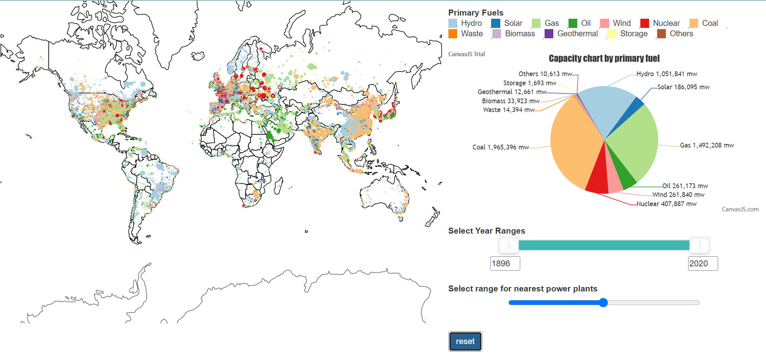

Figure : Final Visualization

The user can use the **Map** to choose a specific country to view the power plants in that country. A legend to the right of the map indicates which hue represents which type of fuel. The power plants are represented as bubbles, with the larger the bubble, the more capacity it generates.

The **Pie** chart displays the overall capacity of all fuel kinds and fluctuates depending on the map selected. So that when a user clicks on a certain country on the map, the pie charts change, and we can view the various fuel capabilities in that region.

The graphic additionally has a **Year slider**. It displays the year of commissioning (starting year of the power plant). As a result, when a user uses the slider to pick a specific range, the pie and map both updates.

There will be a single **Reset button** that will refresh the visualization from the current page to the initial page.

There is a **radius slider** that may be used to discover power plants within a certain radius of a selected power plant. This feature can be used to determine the hazard factor of a specific power plant so that we can avoid future accidents, or if there is a plan to build a new plant where we can do so without causing any disruptions to the public.

A **Tooltip** is used to learn about the characteristics of a power plant. When you click on a power plant on the map, a pop-up window will appear with further information such as the nearest power plant, fuel type, electricity generated, and so on.

The map also has a **Zoom** function. So that the user can zoom in and out of the map using the scroll up and scroll down buttons. This will allow the user to see the details of the power plant more clearly.

### Evolution of design:

The design evolved using a five-sheet design process (Roberts, Ritsos, & Headleand, 2011). The figures below describe five sheets.

After going through all four design sheets, we created a prototype with power bi to demonstrate that this is also achievable in D3.

**Sheet_1-**

**Ideas-** The Idea of this Visualization is to know How is one fuel type replacing other fuel types and how can we see the trends over the years?

**Filter**- To visualize we only need lat and lon of each country, country names, Capacity of a power plant, Primary fuel type, year they are established, and we don’t need owner name, source of data, estimated and generated capacity data. So, we are filtering them.

**Categorize**- The commissioning data, Capacity of power plants, year selector, Different fuel types and Country selection should be together to work together.

**Combine and Refine-** We can add all the above categories into a single page and maybe we can select one or more countries data to visualize at a time.

**Question**- How does one country changing its energy generation category over time?

**Sheet_2,3,4-**

**Information-**

**Title-** Power Plant Data

**Author-** Rakesh & Teja

**Date-** 07-11-2022

**Task-** How does one country changing its energy generation category over time?

**Operations –**

1)     We can select a particular country by clicking the mouse on the Horizontal bar chart

2)     After selecting a country, we can use the commissioning year slider to slide the bar from left to right to see how the country primary fuel sources are changing over time.

**Focus-**

If the user wants to select a country, he can simply click on the county

If we want to select multiple countries, we need to press ctrl and select the countries at the same time.

**Discussion-**

**Advantage-** By using this type of visualization the user needs to carefully see how the changing is happening over the time.

**Disadvantage-**

1.      while changing the year slider if the user is unable to track the map and if he tries to see the data using the pie chart then it becomes difficult for him.

2.      It becomes difficult for the user to select 10 countries at the same time as he must select each and everyone separately.

**Layout-**

1)     Selecting USA Country between 1936 and 2020

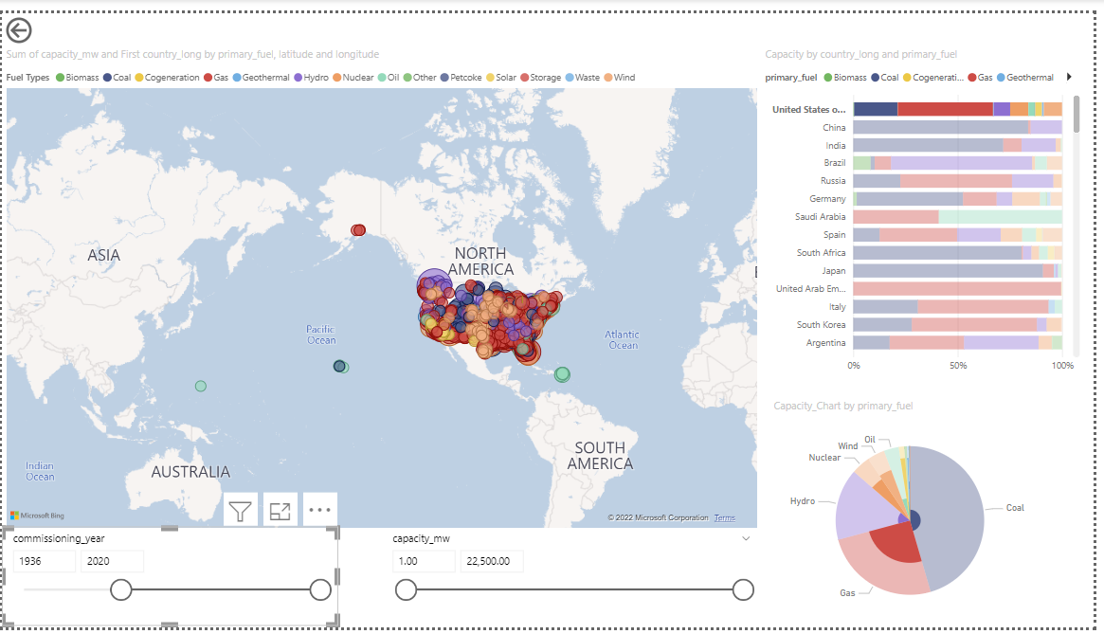

2)      Selecting USA Country between 1936 and 1961

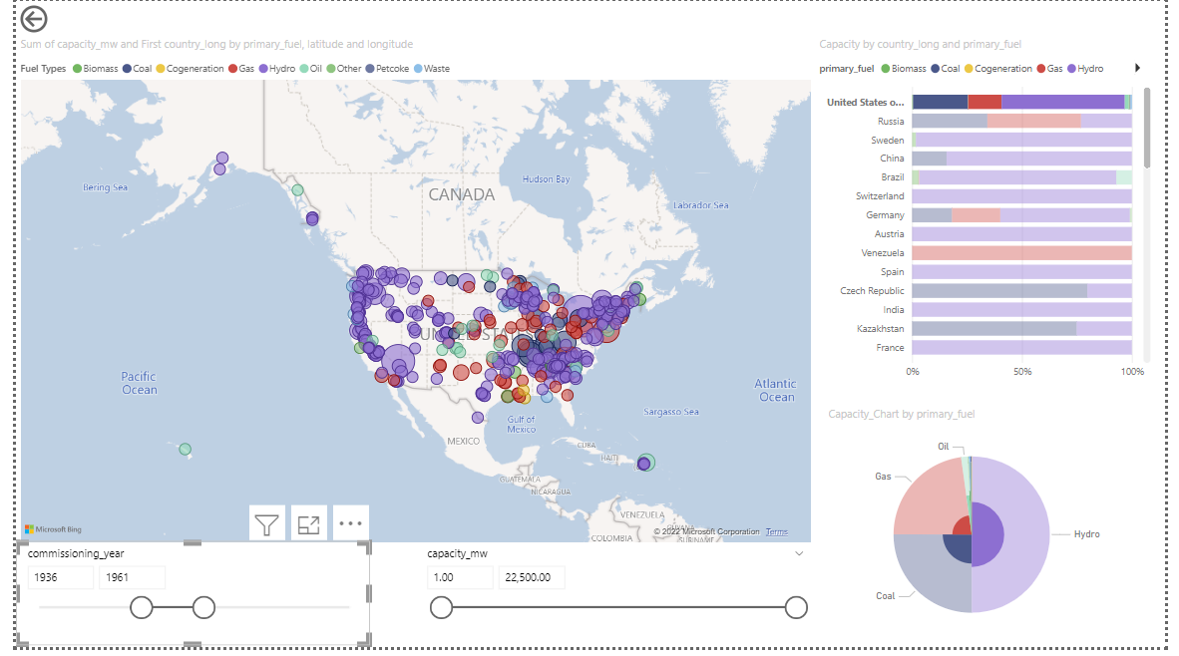

3)     selecting multiple countries between 1936 and 1990 years

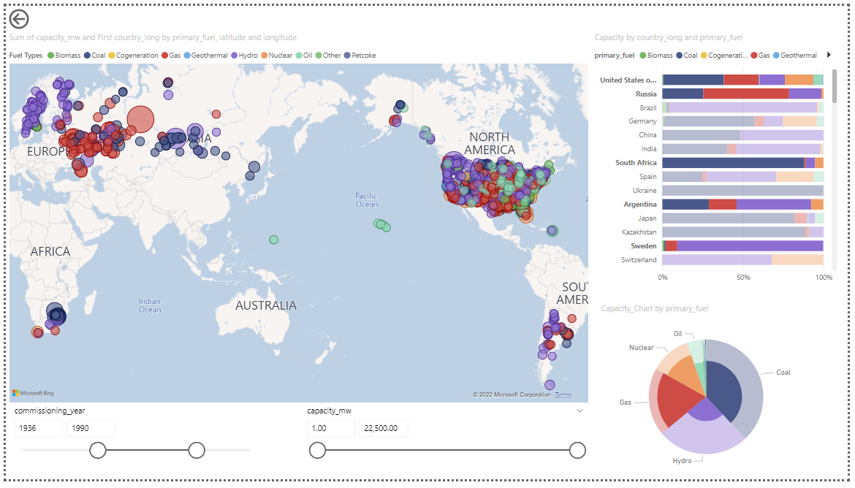

**Findings from layout-**

From figure 2 and 3 the USA country has changed from HYDRO to GAS.

**Sheet_5- Final Prototype design**

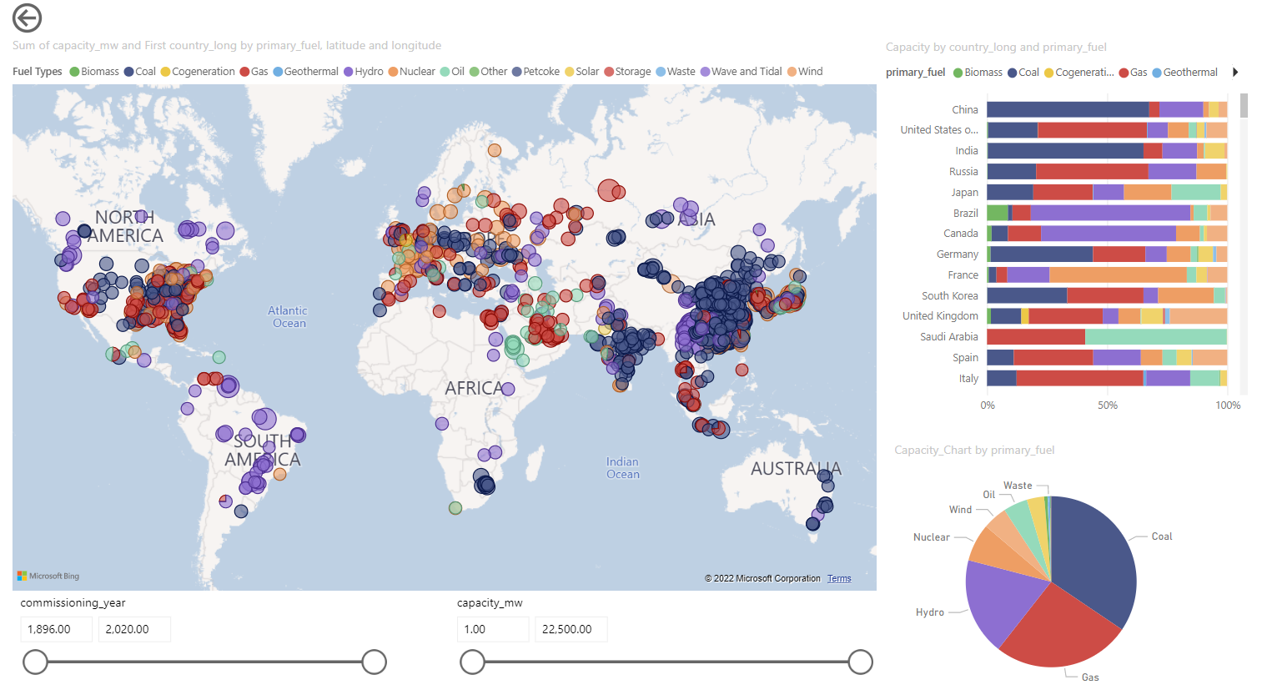

Figure : Final Prototype design

### Marks and channels:

In the visualization, marks and channels are utilized to indicate various aspects.

Some of them are listed below.

Power Plant - To illustrate data for power plants, we use distinct colors for each fuel type.

Power plant capacity - The form of the bubble represents the amount of energy produced.

Color of fuel - Each fuel type is represented by a different color.

|  |  |  |
| --- | --- | --- |
| Attribute | Marks | Channel |
| Power Plant | Points (circle) | Depends on fuel type color, Position |
| Power plant Capacity | Points (circle) | Bubble size |

### Techniques to build the application:

1. D3.js, Bootstrap - Used to make interactions between plots and Zoom effect.
2. 3rd party library (Canvas JS) – Used to plot the Pie chart
3. Geo JSON – Used to make map viz
4. Swatches – Used to Make Fuel type Legend
5. used NoUIslider to create year range slider

# Visualization to Answer the question:

### How does the country's geographical location influence on type of power plants?

We may use this picture to examine how geographical location is related to primary fuel output.

We can answer many questions, such as how a country can use natural renewable resources such as geothermal, solar, and so on to generate power, and how people believe that hydro power is linked to coastal areas, such that if a country has a larger coastal area, it will try to generate more power using its natural resources. However, after viewing the graphic, we can observe that certain countries follow, and others do not. So, it's not entirely accurate to suggest that coastal areas are associated with primary energy production.

The visualizations below show that, even though the United States has longer coastlines than India. They mostly rely on non-renewable energy sources such as gas and coal. On the other hand, despite having a smaller coastline than the United States, Brazil's primary energy source is hydro.

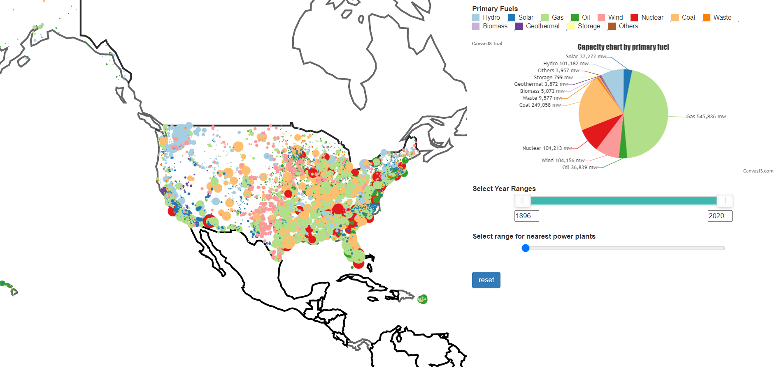

Figure : USA’s main Fuel is GAS

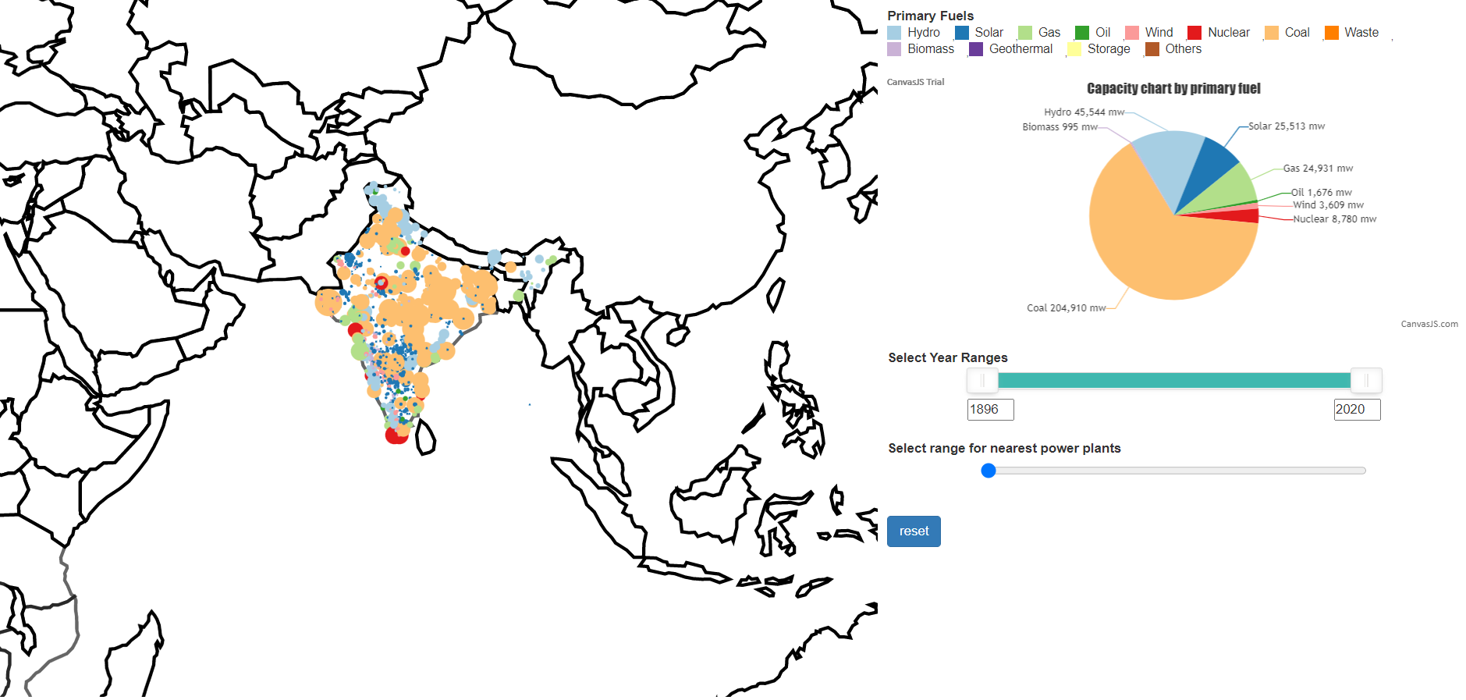

Figure : INDIA’s main fuel type is COAL

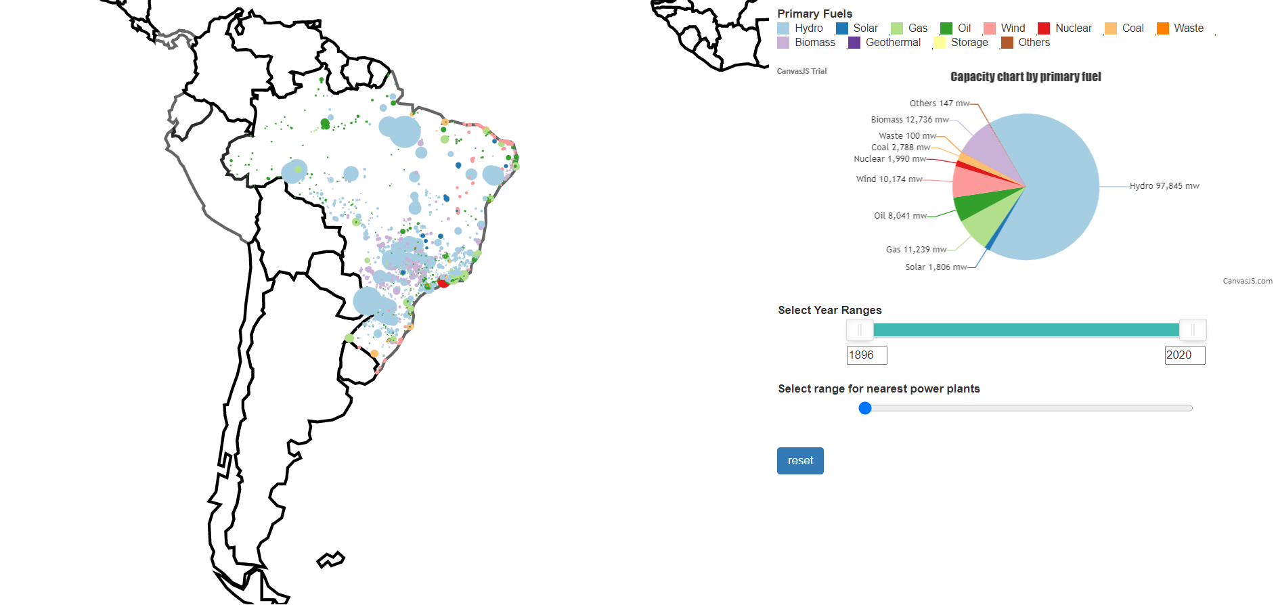

Figure : BRAZIL’s main fuel type is HYDRO

### Where did the initial power plant start and how is the growth of power plants across the world over the years?

The year slider option in the Visualization allows the user to slide the white slider from the year 1896 to the year 2020. And can see the initial locations of power plants as well as the growth of power plants around the world over time.

Using this slider, the user can observe how each country is racing towards carbon-neutral energy and which country has begun experimenting with what type of fuel energy, for example, the United States was the first to use hydro power and Russia was the first to use gas as its major fuel.

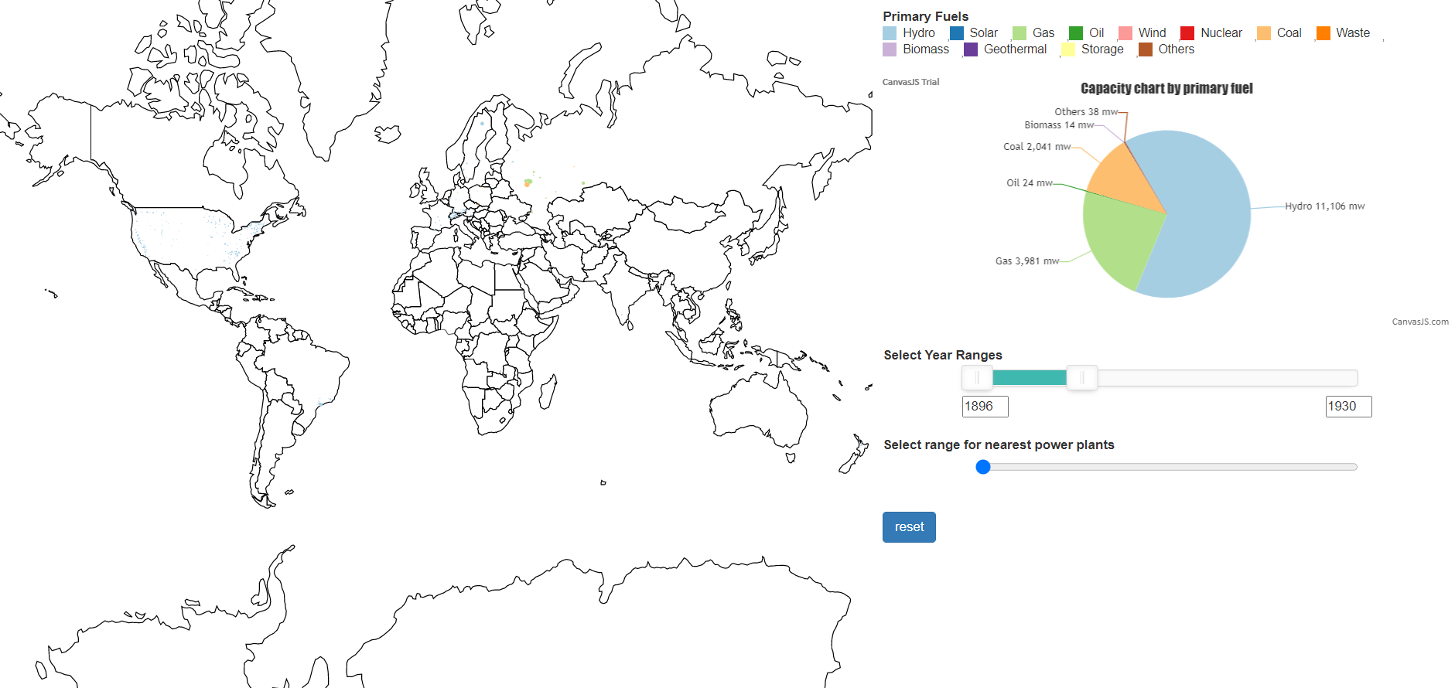

Figure : Power Plants Between 1896 and 1930 in the World

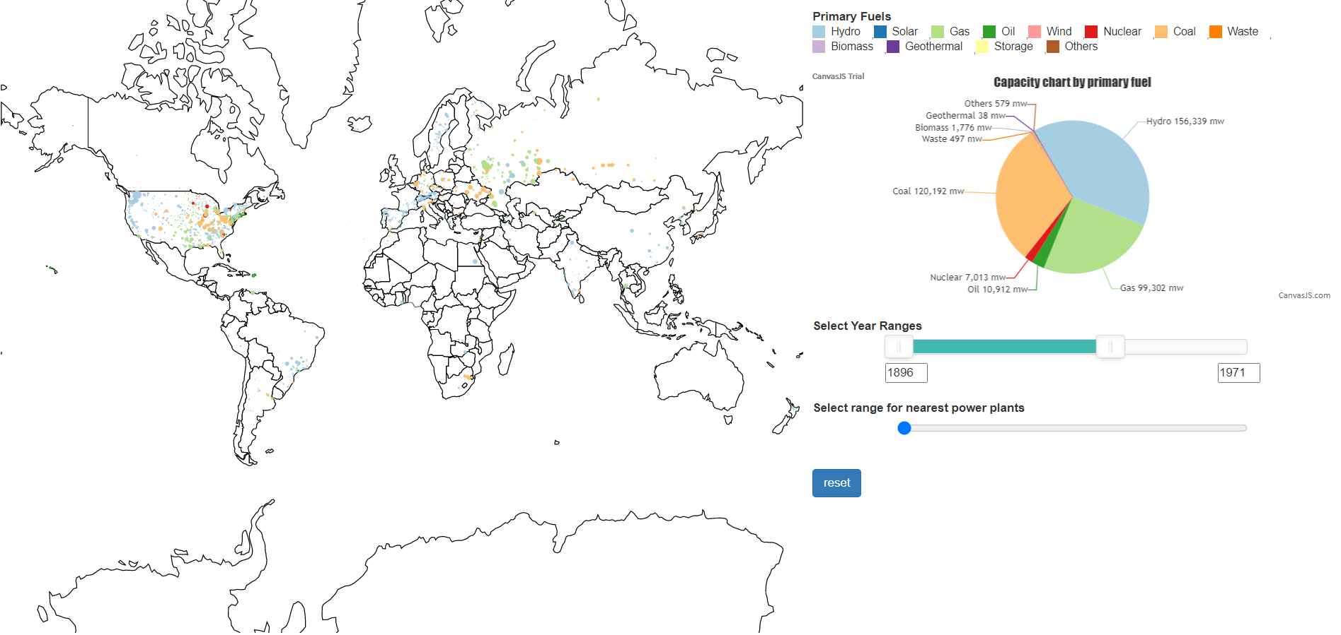

Figure : Power Plants Between 1896 and 1971 in the World

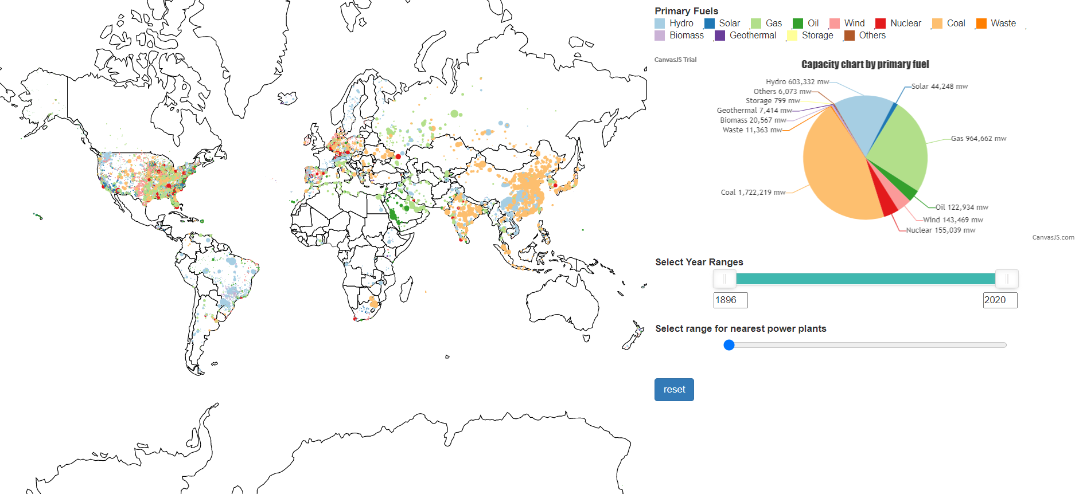

Figure : Power Plants Between 1896 and 2020 in the World

### 

### How is one fuel type replacing other fuel types and how can we see the trends over the years?

Using the interactive graphic, we can observe how countries such as the United States and India have shifted their primary fuel sources from hydro to coal through time, as well as how other countries have done so.

This is important to understand because we may compare this data to demographic data or other data to gain insights. Alternatively, we can use these visualizations to determine whether countries are rushing toward a carbon-free future.

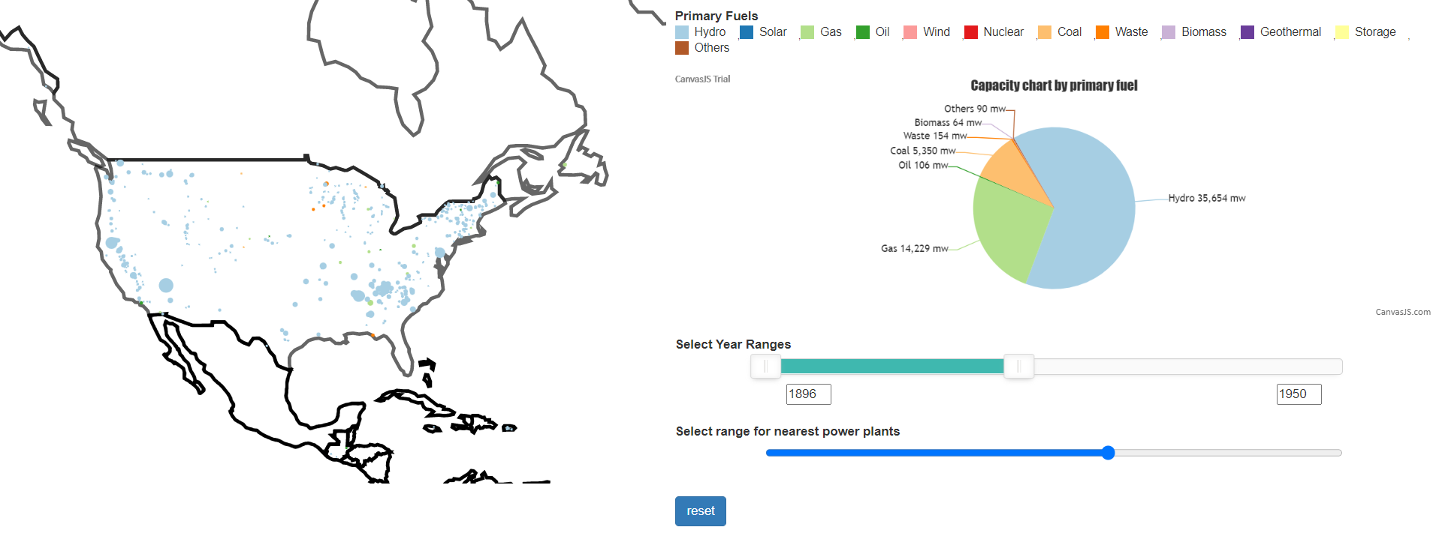

Figure : HYDRO is the primary fuel for USA between 1896 and 1950



Figure : GAS is the primary fuel for USA between 1896 and 2020

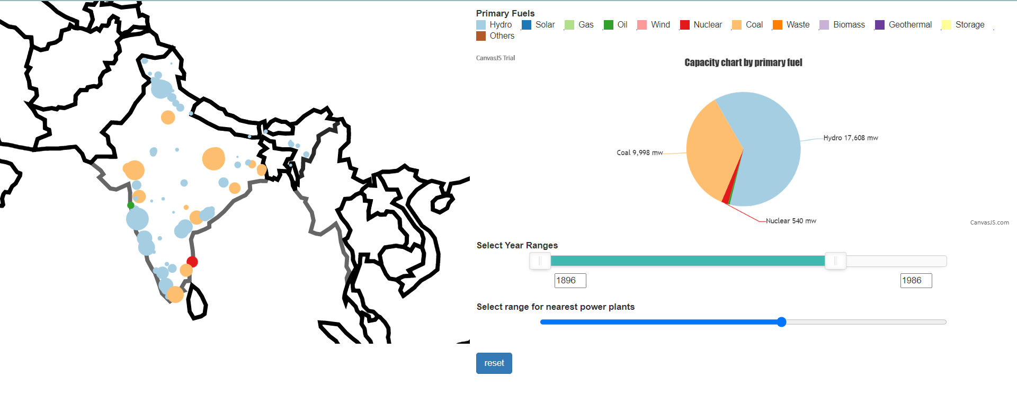

Figure : HYDRO is the primary fuel for INDIA between 1896 and 1986

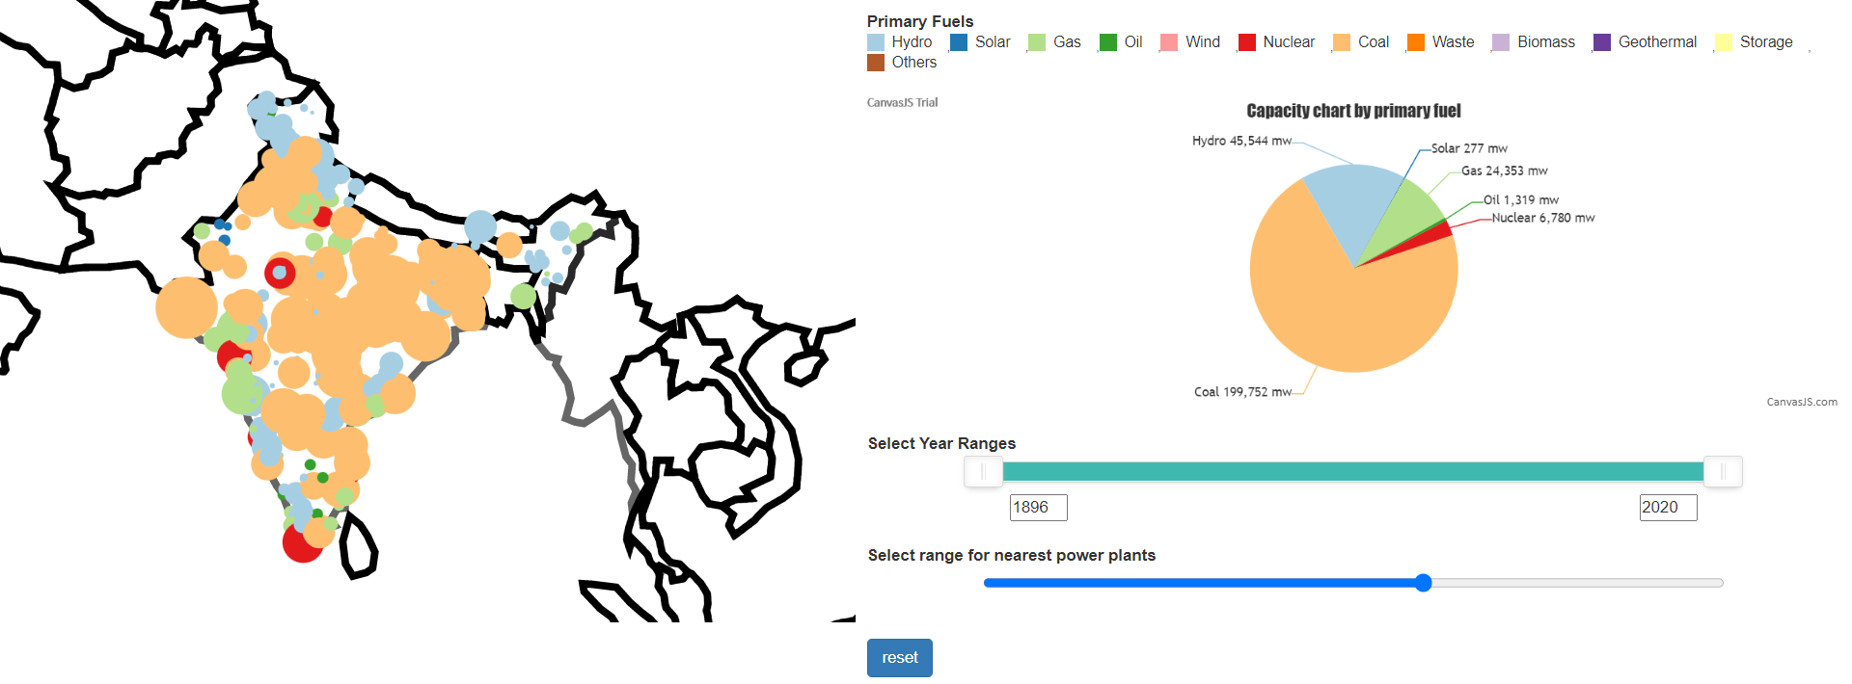

Figure : COAL is the primary fuel for INDIA between 1896 and 2020

### What is the closest power plant to a particular power plant?

To locate the nearest power plant to a given power plant. The first step is to choose a power plant from among the thousands available. The second step is to use the radius slider in the Visualization to select the required radius.

This feature is used to locate power plants within a user-specified range and can be used by utility providers to boost their productivity and supply chain.

The first figure below depicts the first option, while the second depicts the second option.

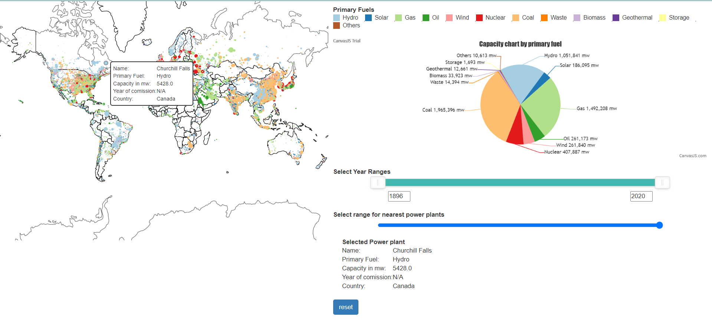

Figure : User selecting a power plant by clinking on it

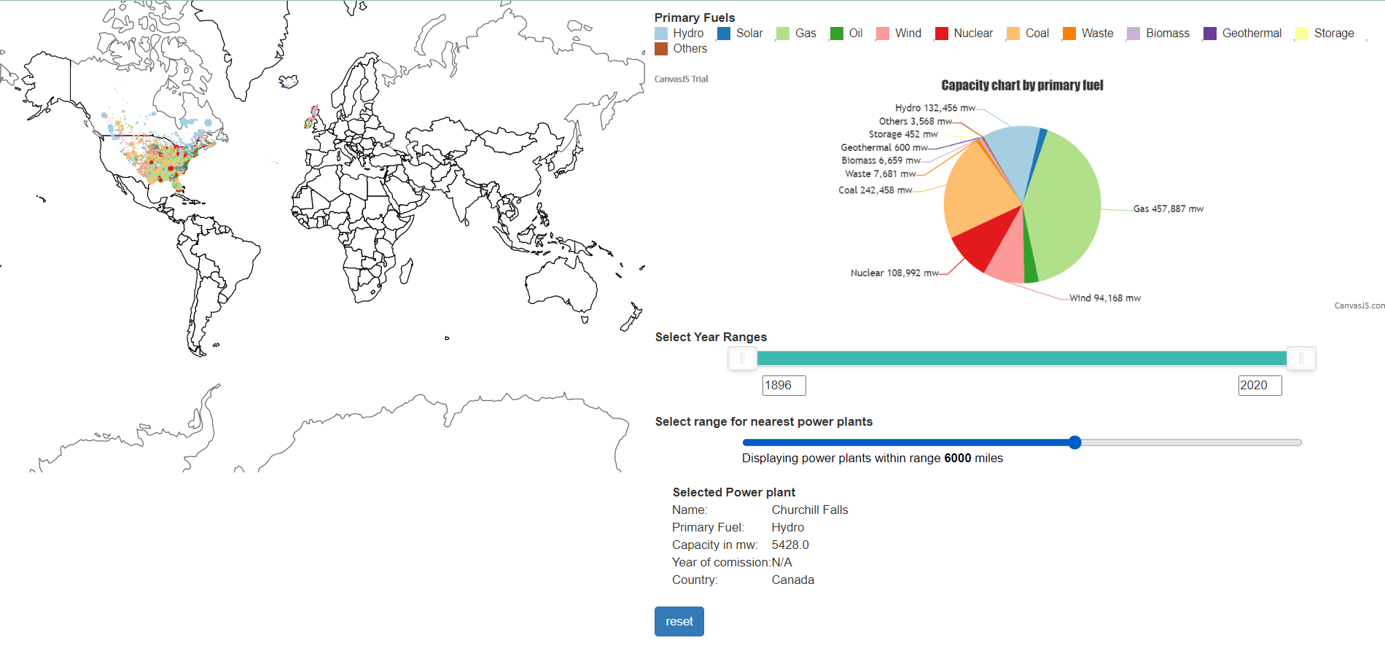

Figure : user selecting the radius using a slider

### What is the attribute of a particular Power Plant in the world?

To find the attributes of a power plant, the user can click on any power plant in any country, and a pop-up window will appear, displaying the contents of the targeted power plant, such as

The name of the power plant. Primary Fuel- The type of primary fuel utilized by power plants, such as coal, gas, and hydro, among others. Power plant capacity - The maximum capacity that a power plant can generate is specified. The year of commissioning informs us about the start of the power plant.

With these characteristics, the user can have a thorough understanding of the specifics of a power plant.

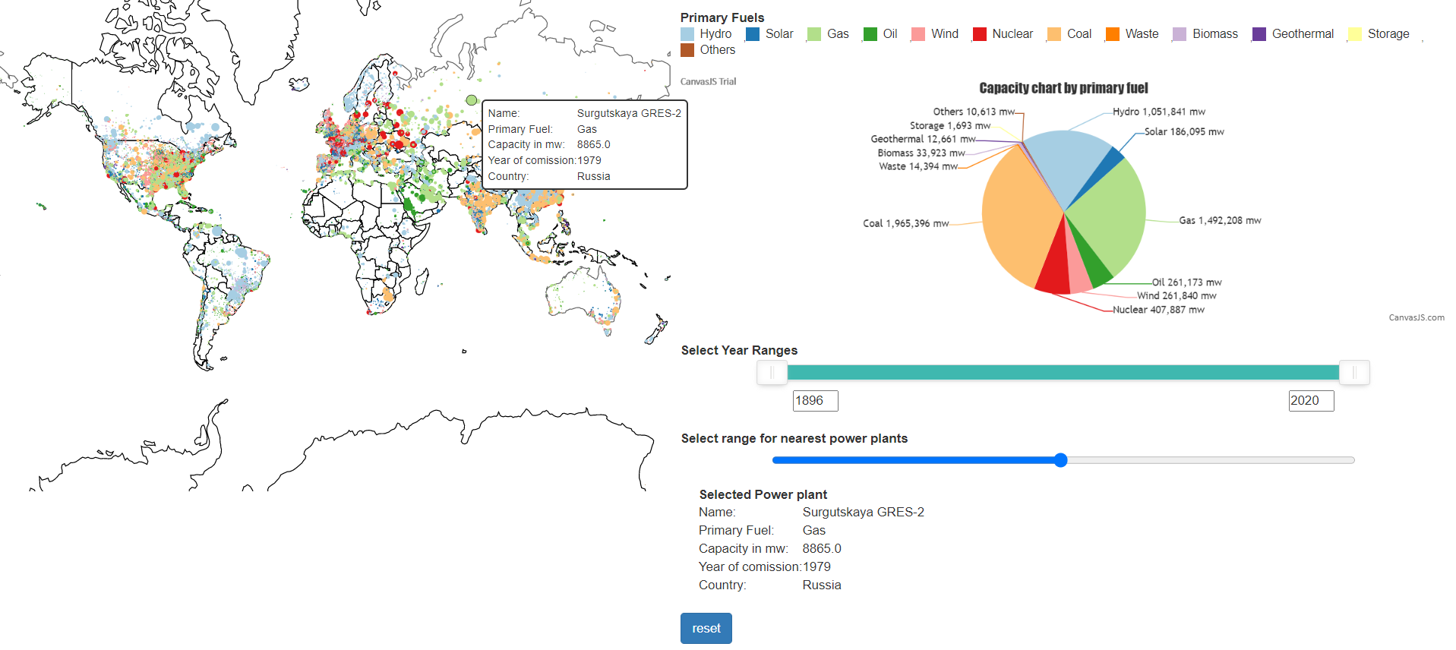

Figure : when user selects a power plant its attributes are displayed

# Limitations and future work:

We were unable to create all the visualizations we desired due to time constraints during the semester. Here are some restrictions.

1.The visualization must include a line plot with the x-axis representing commissioning years, the y-axis representing power plant capacity, and the legend representing fuel type. So that when a user selects a specific country, the line chart updates accordingly, allowing us to monitor the patterns in power plant capacity statistics over time. This can be used to detect any anomalies or to determine when there was a peak in energy consumption and how it relates to other fields such as politics or pandemics, among others.

2. We can also see how the secondary and primary fuels are connected. And see if we can glean any insights from it.

# References:

• J. Roberts, P. D. Ritsos, and C. J. Headleand (2011). 5 Design Sheets Obtainable from Five Design Sheet: http://fds.design/

• D3 mapping - https://www.d3indepth.com/geographic/

• Canvas API - https://developer.mozilla.org/en-US/docs/Web/API/Canvas API

• D3 swatches for a fuel type legend - https://observablehq.com/@d3/color-legend

• NoUISlider - https://refreshless.com/nouislider/ - to create a slider for commissioning years

• Bootstrap for JS (https://getbootstrap.com/)